**Name: LAIBA ASIF**

**Student Number: R00201303**

**Class Group: COMP1DY**

**Lab 5 – De Morgan’s Theorem and Basic Circuits**

1. Prove the following theorems of De Morgan by completing the following tables. Verify this theorem in Logisim using appropriate circuits:



$\overline{A.B}= \overline{A}+ \overline{B}$

$\overline{A+B}= \overline{A} . \overline{B}$

|  |  |  |  |  |  |  |
| --- | --- | --- | --- | --- | --- | --- |
| A | B | $$\overline{A}$$ | $$\overline{B}$$ | $$A.B$$ | $\overline{A.B}$ | $$\overline{A}+ \overline{B}$$ |
| 0 | 0 | 1 | 1 | 0 | 1 | 1 |
| 0 | 1 | 1 | 0 | 0 | 1 | 1 |
| 1 | 0 | 0 | 1 | 0 | 1 | 1 |
| 1 | 1 | 0 | 0 | 1 | 0 | 0 |

### Circuit:

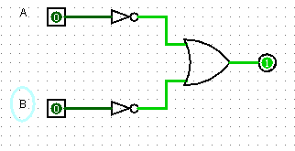

|  |  |  |  |  |  |  |
| --- | --- | --- | --- | --- | --- | --- |
| A | B | $$A+B$$ | $$\overline{A}$$ | $$\overline{B}$$ | $$\overline{A+B}$$ | $$\overline{A} . \overline{B}$$ |
| 0 | 0 | 0 | 1 | 1 | 1 | 1 |
| 0 | 1 | 1 | 1 | 0 | 1 | 0 |
| 1 | 0 | 1 | 0 | 1 | 1 | 0 |
| 1 | 1 | 1 | 0 | 0 | 0 | 0 |

**Circuit**:

2. Draw 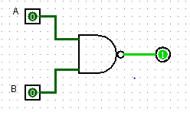 circuits for the Boolean expressions outlined below. Complete the truth tables for these expressions and verify the truth tables using your circuits,

$\overline{x.y}.z+\overline{x}$

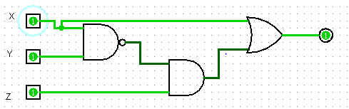

|  |  |  |  |  |  |  |  |
| --- | --- | --- | --- | --- | --- | --- | --- |
| X | Y | Z | X.Y | NOT X.Y | NOT X | NOT X.Y.Z | NOT X.Y.Z +NOT X |
| 0 | 0 | 0 | 0 | 1 | 1 | 0 | 1 |
| 0 | 0 | 1 | 0 | 1 | 1 | 1 | 1 |
| 0 | 1 | 0 | 0 | 1 | 1 | 0 | 1 |
| 0 | 1 | 1 | 0 | 1 | 1 | 1 | 1 |
| 1 | 0 | 0 | 0 | 1 | 0 | 0 | 0 |
| 1 | 0 | 1 | 0 | 1 | 0 | 1 | 1 |
| 1 | 1 | 0 | 1 | 0 | 0 | 0 | 0 |
| 1 | 1 | 1 | 1 | 0 | 0 | 0 | 0 |

$x.\overline{y}+\text{y.}\text{z}$

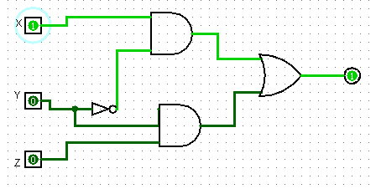

|  |  |  |  |  |  |  |
| --- | --- | --- | --- | --- | --- | --- |
| X | Y | Z | NOT Y | X. NOT Y | Y.Z | X.NOT Y+Y.Z |
| 0 | 0 | 0 | 1 | 0 | 0 | 0 |
| 0 | 0 | 1 | 1 | 0 | 0 | 0 |
| 0 | 1 | 0 | 0 | 0 | 0 | 0 |
| 0 | 1 | 1 | 0 | 0 | 1 | 1 |
| 1 | 0 | 0 | 1 | 1 | 0 | 1 |
| 1 | 0 | 1 | 1 | 1 | 0 | 1 |
| 1 | 1 | 0 | 0 | 0 | 0 | 0 |
| 1 | 1 | 1 | 0 | 0 | 1 | 1 |

$z+\overline{x}. \overline{z}$

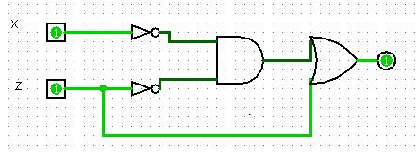

|  |  |  |  |  |  |
| --- | --- | --- | --- | --- | --- |
| x | z | Not x | Not z | Not x. not z | Z + not x. y not |
| 0 | 0 | 1 | 1 | 1 | 1 |
| 0 | 1 | 1 | 0 | 0 | 1 |
| 1 | 0 | 0 | 1 | 0 | 0 |
| 1 | 1 | 0 | 0 | 0 | 1 |

3. Using the Sum of Products technique, design a circuit which implements the following truth table. The inputs are A, B, and C. The output is X

**Truth Table:**

|  |  |  |  |
| --- | --- | --- | --- |
| **A** | **B** | **C** | **X** |
| 0 | 0 | 0 | **1** |
| 0 | 0 | 1 | **1** |
| 0 | 1 | 0 | **0** |
| 0 | 1 | 1 | **0** |
| 1 | 0 | 0 | **1** |
| 1 | 0 | 1 | **1** |
| 1 | 1 | 0 | **0** |
| 1 | 1 | 1 | **0** |

**Circuit:**

